# Release note of Bigmart Ordering System on July 12th, 2017

The changes and updates made in Ordering system are listed below.

1. Error message "The sales record on your system is already a week old. Please, import latest sales record to continue Allocation." message is displayed if the fresh long order is calculated but the sales data is a week old.

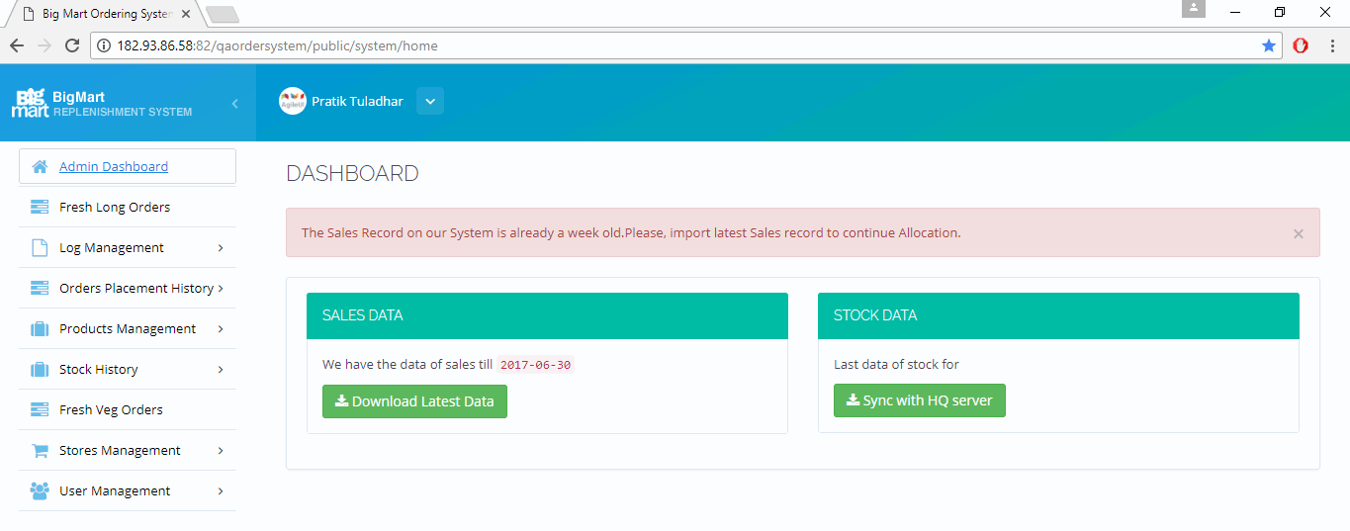

1. Error message "The Stock Record on our System is not of current date. Please, import latest Stock record to continue Allocation." is displayed if the fresh long order is calculated but the stock data is not of the latest date.

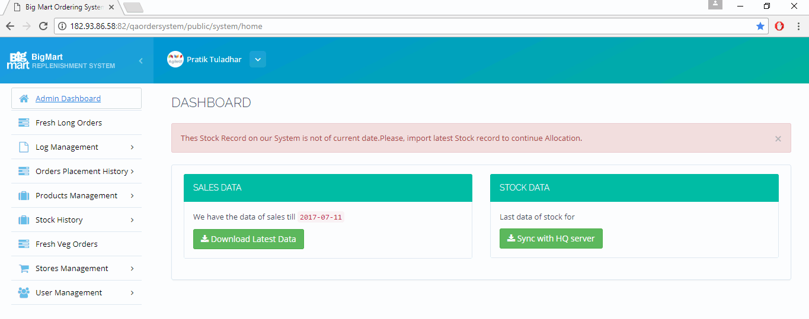

1. Some items from fresh long having no MBQ in any stores were displaying in the list. These items have been removed from the list.

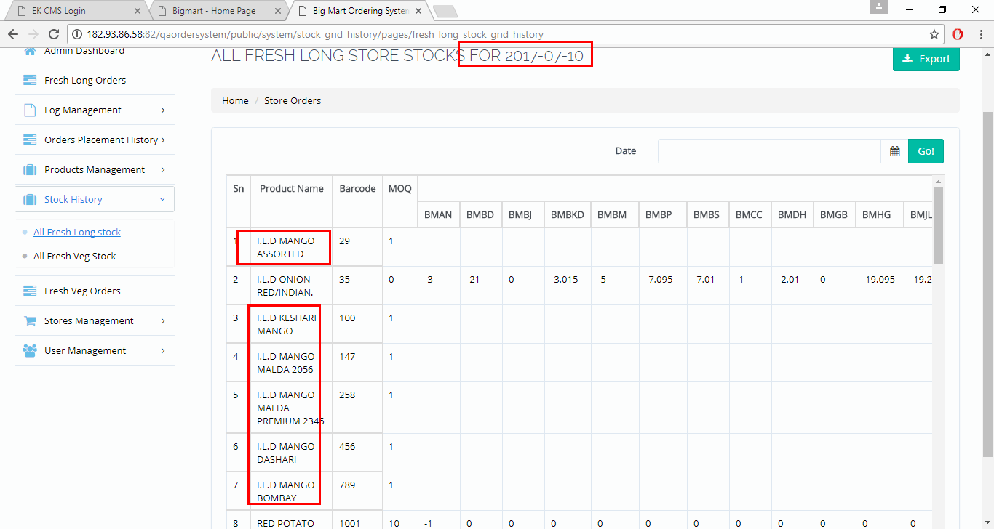

1. The return value in the Fresh long allocation sheet was displaying many long digits after decimal. This issue has been solved.

